Tim Tognazzini
Tim.Tognazzini@Fabricut.com
Abstract
This document discusses how to use Microsoft Word to format documentation like this document. The intent is to provide a consistant look and feel and well as feature set to the documentation created at Fabricut.
Documentation Standards
How to create documents like this.

Table of Contents

Cover Pages
Every document will contain a title page. It is always the first page of the document. This document has one you can look at as an example.

Adding a Cover Page
To add a cover page, move your cursor to the start of the document, go to the insert tab at the top, click cover page and select Facet from the list.
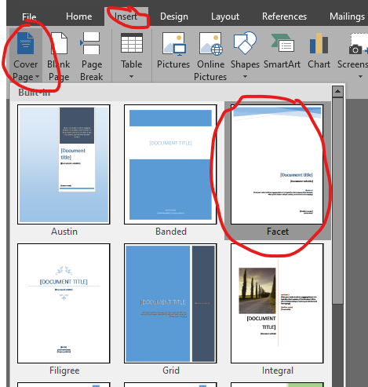
The page will be inserted and there will be fill in the blank text fields for you to populate. Fill in the Title, sub title, abstract and any other fields needed. Some may auto populate for you.
Highlight the word Abstract and set the alignment to left, do the same for the data typed in the abstract field. This field looks a little weird when it is left left justified.
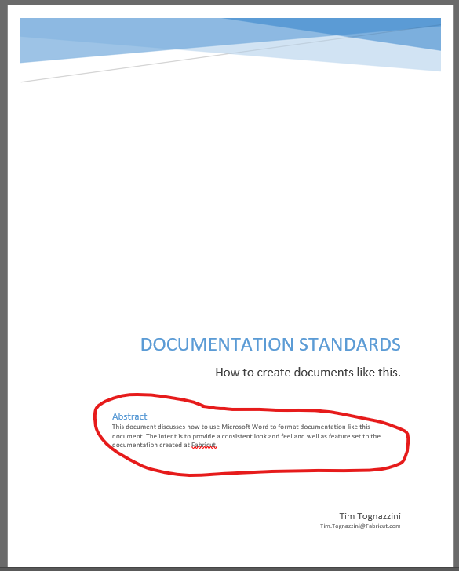

Table of Contents/Navigation
The table of contents and navigation are automatically created using the headings. For this to work all headings must use styles. The styles are listed on the home ribbon. In general each section starts with a Heading 1 style. An example of this is the heading above this paragraph that reads “Table of Contents/Navigation”.
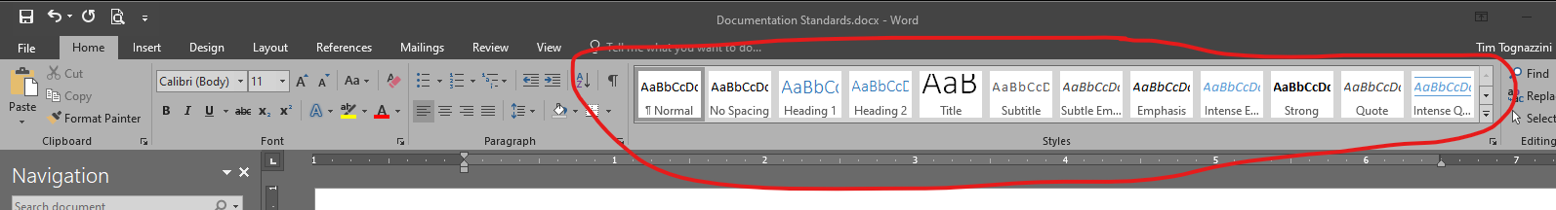
Inside the header section a document can be split up into sub sections using Heading 2 and further split up with Heading 3. All Header type entries will be included in the table of contents and navigation pane.
Do not over use these as it will make a really long table contents and the navigation pane will be hard to navigate. However the document should be broken down in section for ease of navigation. How large a section is depends on how long the documentation is.
Each Header 1 entry should start on a new page. For instance this section start on a new page after the Table of contents. Sub-sections do not start on a new page. Header 1 entries will also create chapters, so lay your document out with that in mind.
The following sub-section show how to use heading 2 and three so you can see how they look in the table of contents. Normally these section would not be included without some meaningful content and a good reason to put them in sections.

Sub-Section (Header 2) Example
There should be some information here.

Sub-Sub-Section (Header 3) Example 1
Some more stuff here.

Sub-Sub-Section (Header 3) Example 2
Some more stuff here.
Look at the navigation pane to see how these are displayed. You will see that each one is indented under the previous. Also each section that has sub-sections can be minimized. In a PDF document they are minimized by default so the user can drill down to the detail they want to see. In word they are all expanded by default. If you do not see the navigation pane in Word you can turn it on on the view tab, see the following image:
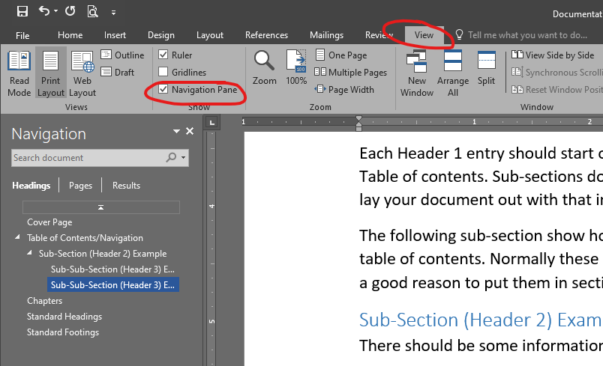
In the table of contents these section are also indented and each one is a link to the location in the document.

Inserting a Table of Contents
A table of contents need to be inserted directly after the title page. The table of contents is auto generated by the system when it is inserted. To insert it move the cursor to the where you want it to go, go to the reference tab, click table of contents and select the first option. See the picture below.
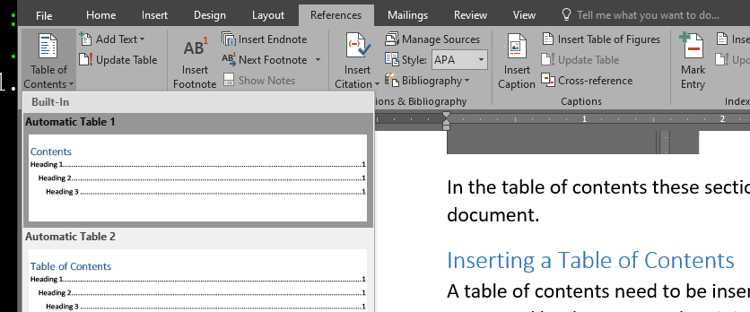
This will insert a table of contents for you based on the headings used in the program at the time of insertion. However this will not automatically update when you or change sections. To update is click anywhere in the table of contents and a tab will pop up at the top of the table that includes an Update Table… link. Click that and you be prompted to update the entire table or just the page numbers. If you have added or changed any section headers you will need to update the entire table. If you have only added content you can use the update page number only option. The picture below shows what these options look like.
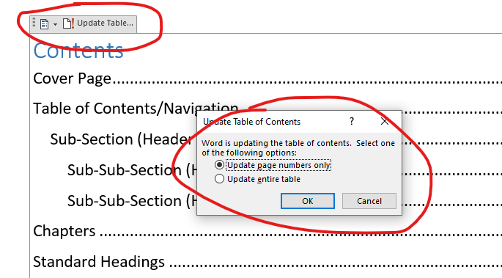

Chapters
Chapter numbers layout the document like a book. They are useful because they affect how the page numbers are displayed. It changes the page numbering to use the chapter number followed by the page in that chapter. To keep all documents consistent we will just use the pre-define chapter option in the multi-level list drop down box.
Each chapter will automatically be setup to use the Heading 1 lines as a new chapter. This will append the word chapter and the chapter number to the start of all lines formatted with Heading 1.

Adding Chapters
Move your cursor to any of the Heading 1 lines, click the multi-level list icon and select the option that show chapter. See the following image for the locations of these items.
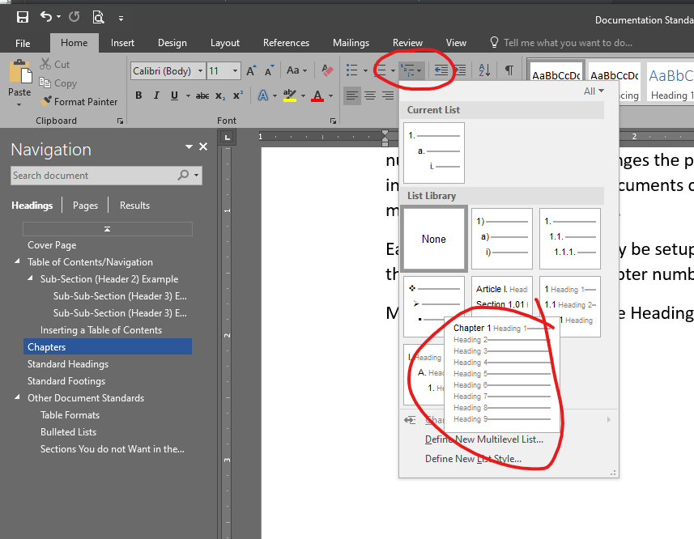

Standard Headings
We want chapter-page numbers for the page headings. This is a standard option under headings. We also want the side to switch between odd and even pages. This makes is to the numbers are on the outside of the pages when the document is printed on both sides and inserted into a binder.

How to add Pager Numbers
To do this we use the header option on the Insert tab at the top of Word. Select the Facet (Even Pages) option.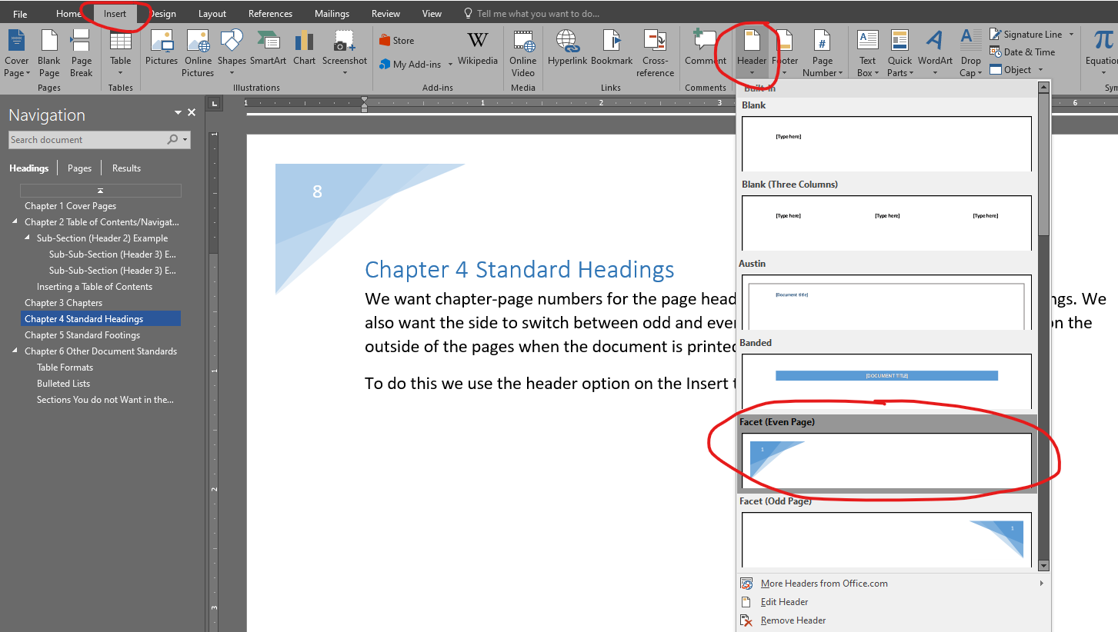
We then need to change the headings for the even and odd pages. To do this double click in the header section of the page, this will be where the new page number were just added. This changes the mode to update the headers. It also automatically displays the Design tab with the header options. Click the check boxes for Different First Page and Different Odd and Even Pages.
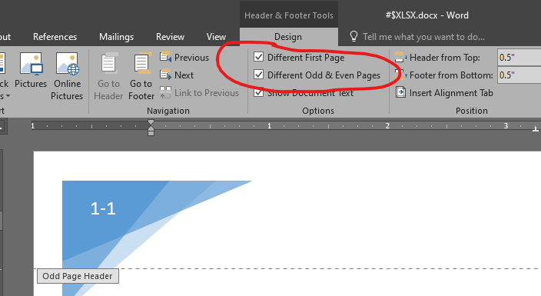
The different first page is because we have a cover sheet. We do not want page numbers on that. The different odd and even pages option is so we can have the page number always me on the outside edge of a printed document. Now we need to set the even page header option. This went blank when we clicked the different odd and even page option because we have not set one yet. The weird thing is that since we have a cover sheet, the odd and even numbers are off, so on an even page we need to the header option Facet Odd Page.
Now we want to change the number to include chapter numbers. We do this using the page number settings dialog. On the insert tab, click the page number box and select Format page numbers.
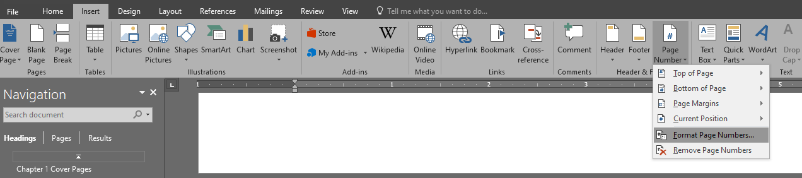
This displays the dialog. Click the Include chapter number check box and leave the rest of the options the same.
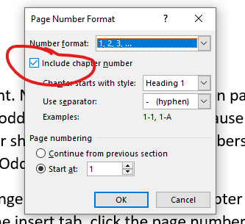
On this document the page number were cut off when they hit page ten. I had extend the size of the field a little to accommodate larger page numbers. I did this by double clicking the page header, then the page number and dragging the dots around the text box out a little. I had to do it on both the even and odd page headers.
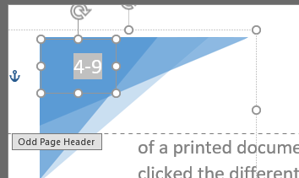

Standard Footings
For the footing we want the current chapter and the first section header. This assists in knowing where you are at when working through a document.

How to Add Standard Footings
We are going to start with the facet footings and then change them around a little. The even and odd pages are still off by one because of the header page. So when you are in the even page footer, choose the Facet Odd option and in the odd page footer choose the Facet Even option.
Start by double clicking the footer of a page. It will put you in footer edit mode, the purpose of doing this is just to see if you are on an even or odd page footer. It will say on a tab above the line separating the footer area from the document area. Select the Footer drop down on the insert tab and select the option. Repeat for the next page to get both the odd and even pages set.
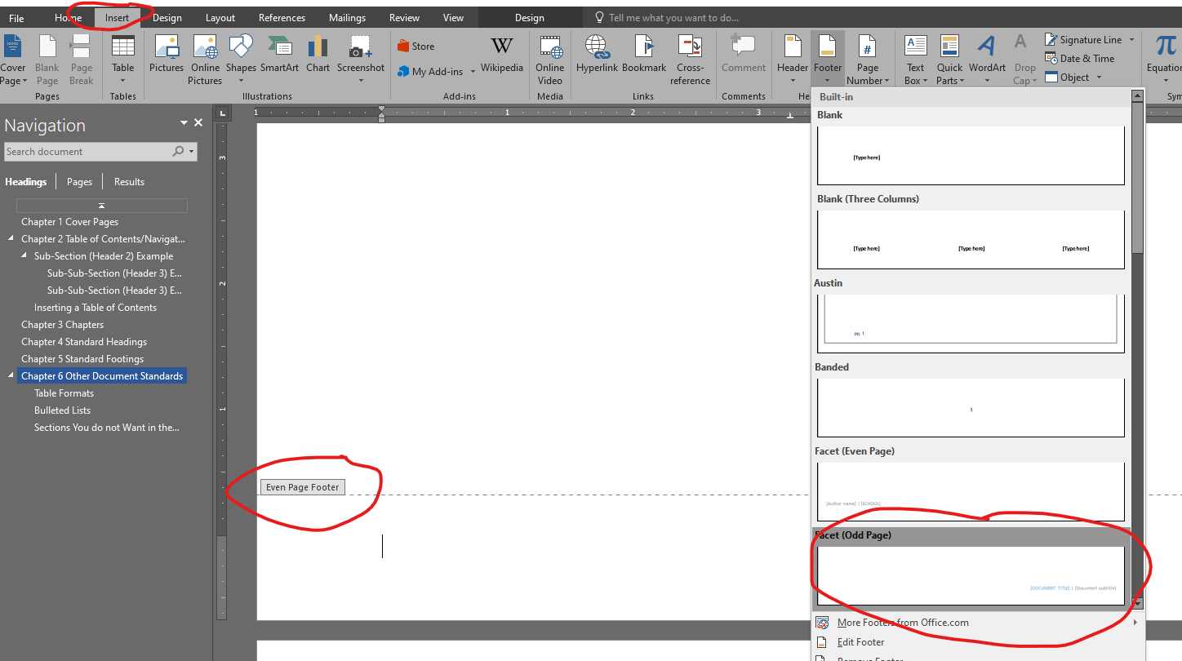
By default the odd page footer shows the document title and sub-title which works well. The even page however shows the company name and author. These are not useful for documentation, so we are going to change them to the chapter and section.
To do this click on an odd page section, which contains an even page footer. Click the authors name and delete the box. Then go to the insert tab and select quick parts and field.
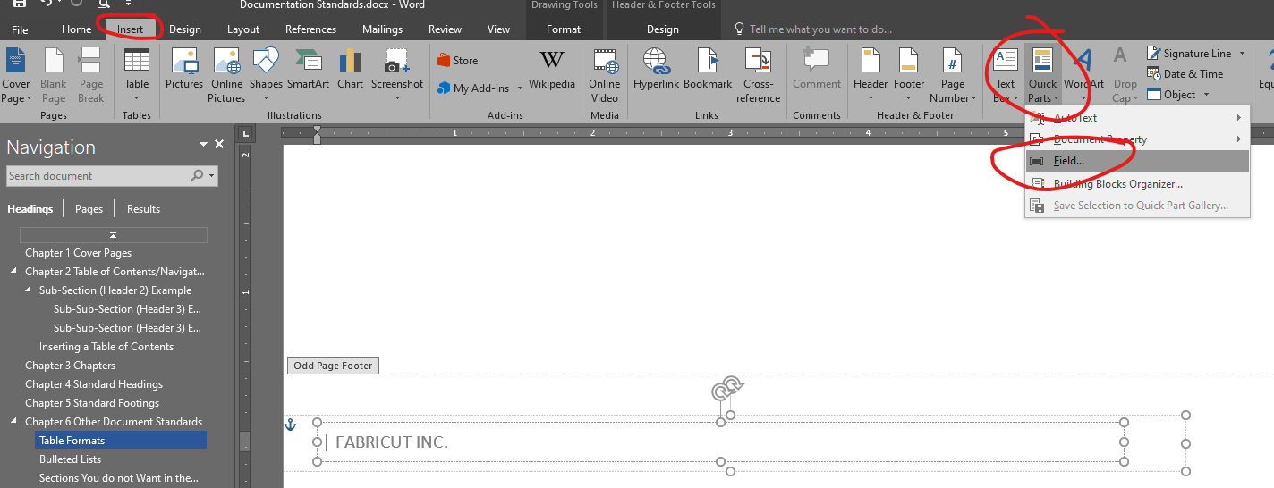
This opens the field dialog box. Select StyleRef for the field name and then Heading 1 for the Style Name and click ok.
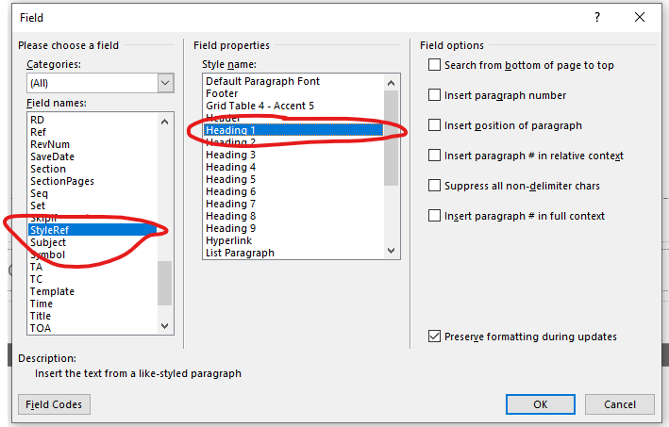
Then delete the company name field, leaving the bar between the two. Again go to the insert tab, select Quick Parts then field. Add another StyleRef, but this time select Heading 2. This adds the section name.
Now to match the format of the Odd page header we need to style the Chapter header blue. Click in the company name, then use the field color box on the home tab to change the color. See the image for which one to select.
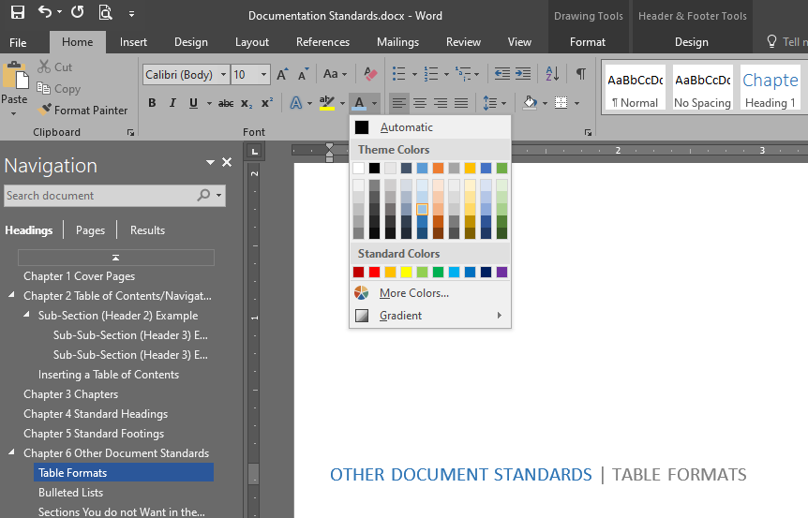
This creates an issue with chapters that do not have sub-sections. They will always display the last subsection used, even if it was from a previous chapter. The only solution I can find is to make sure each chapter starts off with a little text and then has a section header, Header2 style.

Other Document Standards
The following sections discuss some of the other formatting standards.

Table Formats
Since the documents use a blue scheme we want any table to also use a blue scheme. Word has built in table formatting that makes this easy. First create you table and add the data. The with your cursor anywhere in the table the deign tab should be shown, if not click the design tab. There will be a list table styles. In the lower right hand corn of the list click the drop down arrow to expand the list. Then click one of the blue colored table formats. The following table is an example of one looks like. Following that is some picture that who were the table style options are.
Column 1 | Column 2 | Column 3
Some data | More data | More data
Row 2 data | More data | More data

You should select one of the 2 blue option circled. The difference is how the first column is colored. Use the one that makes sense with your data. If you do not want the first column bolded, like in the above example, just highlight it click the bold button on the home tab or use ctrl+b to remove the bolding.
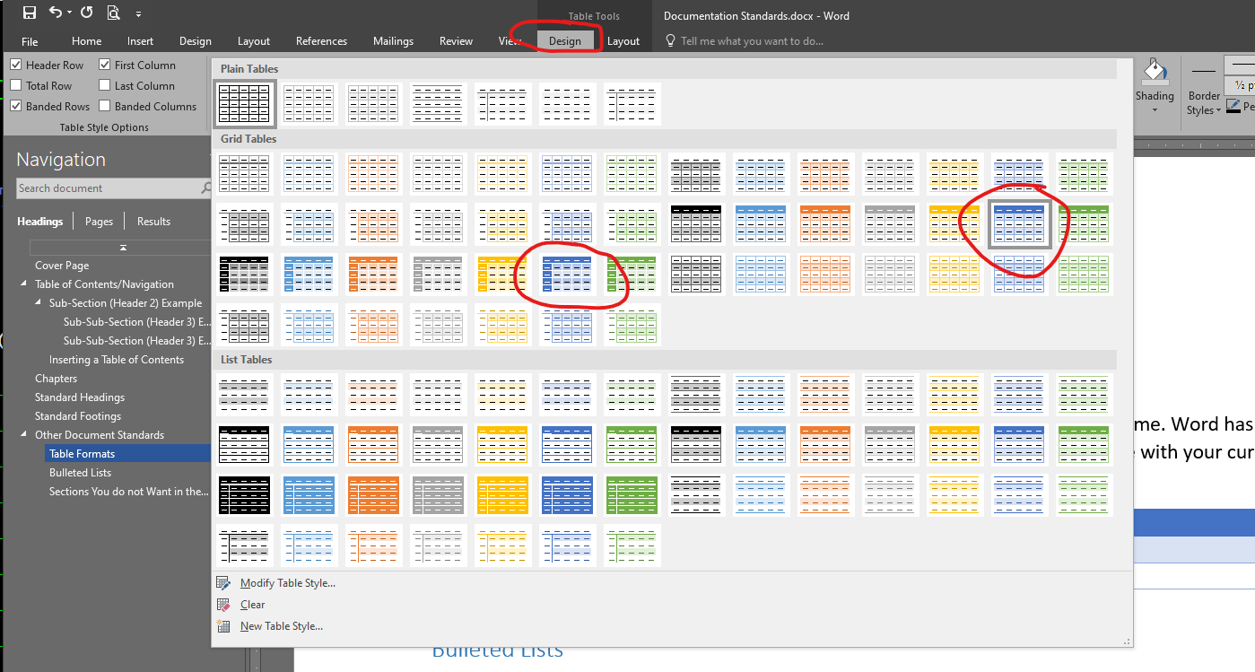

Bulleted Lists
Bulleted lists makes formatting lists easy. They are great to use if you are listing of things. If you are listing steps, use number lists. The following list shows good places to use bullets.
- When your data is a list, any list.
- When the list tends to consist on items that mostly fit on one line
- It is ok the some of the entries stretch to multiple lines. They still look good in a bulleted list. Word automatically maintains the indent to match the list.
- When you do not want multiple entries to have spaces between them.
To create a bulleted list follow these steps. These steps are also an example of a numbered list.
- Type data over multiple lines.
- Highlight the lines you want to be in the list.
- Click either the bullet icon or the number icon.
- Use the defaults so they are consistent, do not use any of the weird options Word allows.
The following image shows where the buttons are for bullets and numbered lists. Once click you can reselect the text and click them again to undo it.
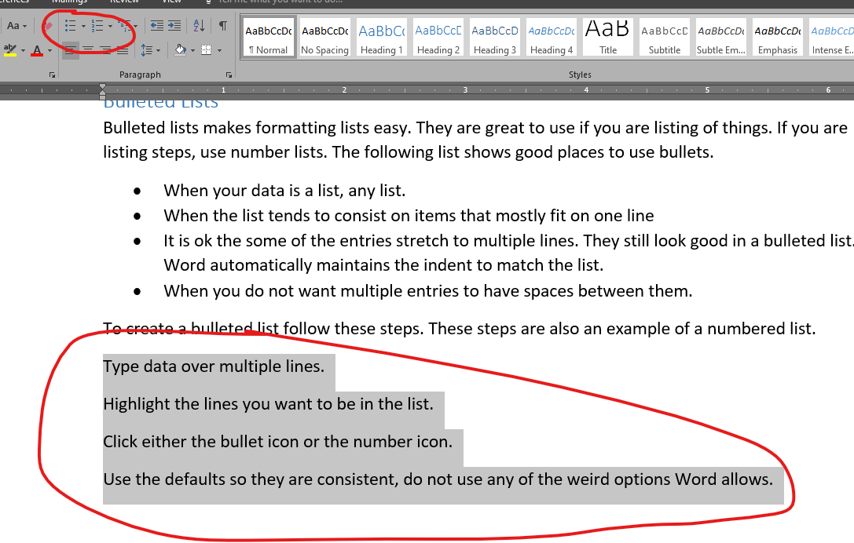

Sections You do not Want in the Contents But Want to Label
There are sometime you want to create section for a list or option that do not show in the navigation pane and table of contents. To do this create you header line, bold it and then remove the space after the paragraph. The following sections walk you through the process and are an example of what it look likes.
Bold the Text
To bold the text highlight it and use ctrl+B or the bold button on the home tab.
Remove the Space After the Paragraph
To do this you just have to have your cursor on the line and then use the drop down box for line spacing and select remove space after paragraph, see the following image.
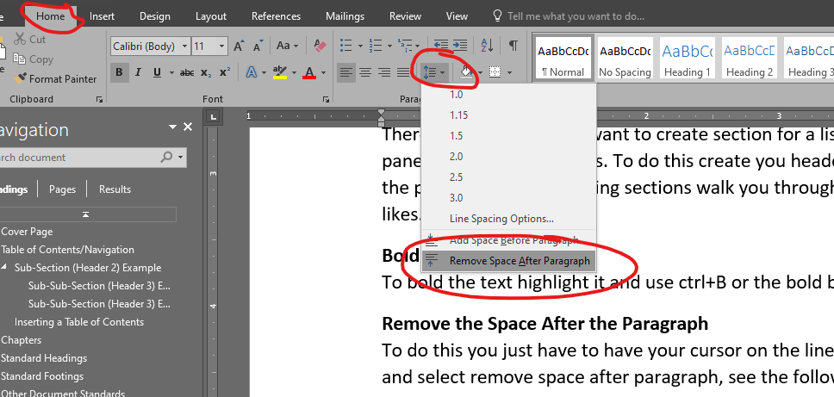
Since these lines do not use a Heading style they will not be included in the contents or the navigation pane.

